**Login Screens**

* Login screen will now retain the “District” name when logging into the app.

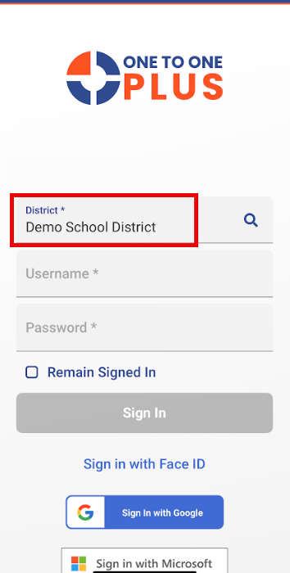

* Face ID (Finger Print on Android) can now be enabled when logging into the app. This can also be disabled at any time by clicking on the setting button at the bottom of the screen.

